TRAINING POLICY

Coverdale k9 Security Services Limited is committed to a structured training and development programme of its staff through vocational and refresher training in order to fulfil the high standards of service required to ensure success and to comply with legislation – Private Security Industry Act 2001.

The Company’s policy statement on training is as follows: -
“To provide training at all levels of such duration and scope as is compatible with the efficient discharge of the task involved and the safety of the employee. Whether conducted “in house” or “contracted out” training at all levels must be conducted by qualified trainers in an environment conducive to effective training.

To provide training at all levels specific to assignment and required specialist skills, also to provide continuation, refresher, and contingency training.

This policy is approved by the Directors and is supported by all levels of management within Coverdale K9 Security Services Limited.
Signed 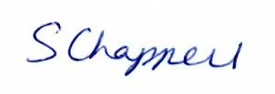
Company Secretary
Issue Date 4 January 2020 Version 2

