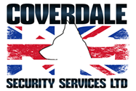

ENVIRONMENTAL POLICY

Coverdale K9’s policy on environmental issues is, in the most part, driven by our customers. It is our practice to work with our customer’s environmental policy framework, as our operations may occur on customer premises.

As an organisation, we communicate care for the environment and encourage all conduct amongst staff and sub-contractors that promotes this, this in practical terms means

- Selected vehicle categories that are fuel efficient
- Use of paperless communication through E-mail
- All paper and ink cartridges go for re-cycling

We will continue to seek ways to protect the environment, our customers, and staff during the course of our business.

Signed

Issue Date 4 January 2020 Version 1

